**Education for Sustainability (EfS) and Cultural Competency (CC):**

**Where are the Connections?**

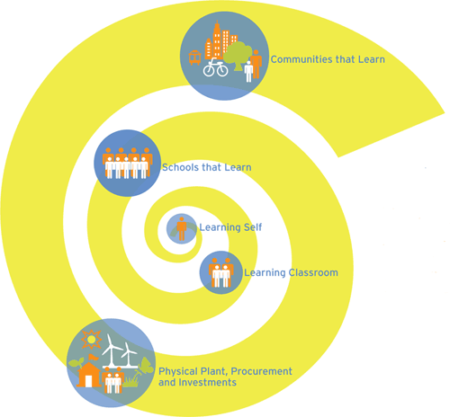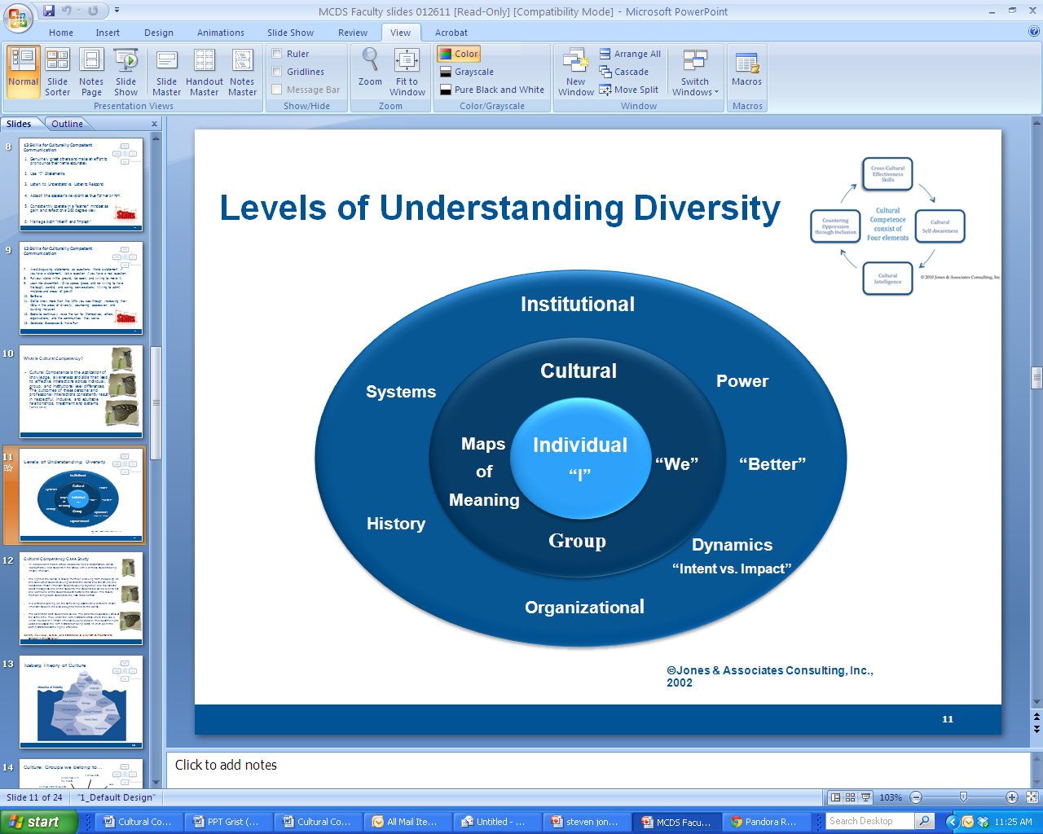

Frameworks from The Cloud Institute for Sustainability Education (left) and Steven Jones (right) describe the components and interrelationships among the components of each field.

**The Most Important Convergence: A Work in Progress…**

1. “The inclusion of diversity is required in order for us to thrive.” -Jones
2. “Diversity makes our lives possible.” -Cloud
3. “The inclusion of diversity is required in order for us to thrive and is a form of Biomimicry (mimics nature).” –Jones/Cloud
4. “Leveraging diversity through inclusion makes our lives possible.” –Jones/Cloud

**Shared Metaphor: the Iceberg**

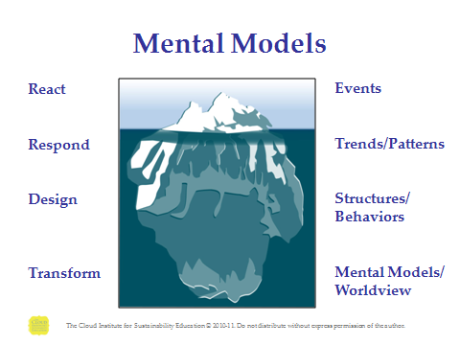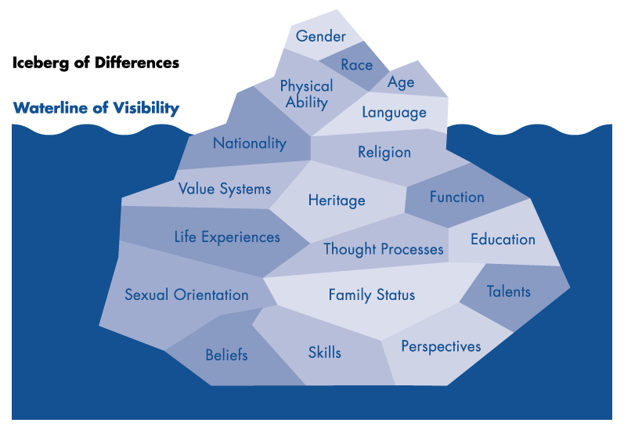

**Thoughts on Mental Models:**

“Everything is internally consistent within the frame we are operating.” -Senge/EfS

“Most people make sense to themselves.” -Jones/CC

“It all begins with a change in thinking.” -Cloud/Jones/EfS/CC

**Shared Metaphor: the Ladder of Inference**

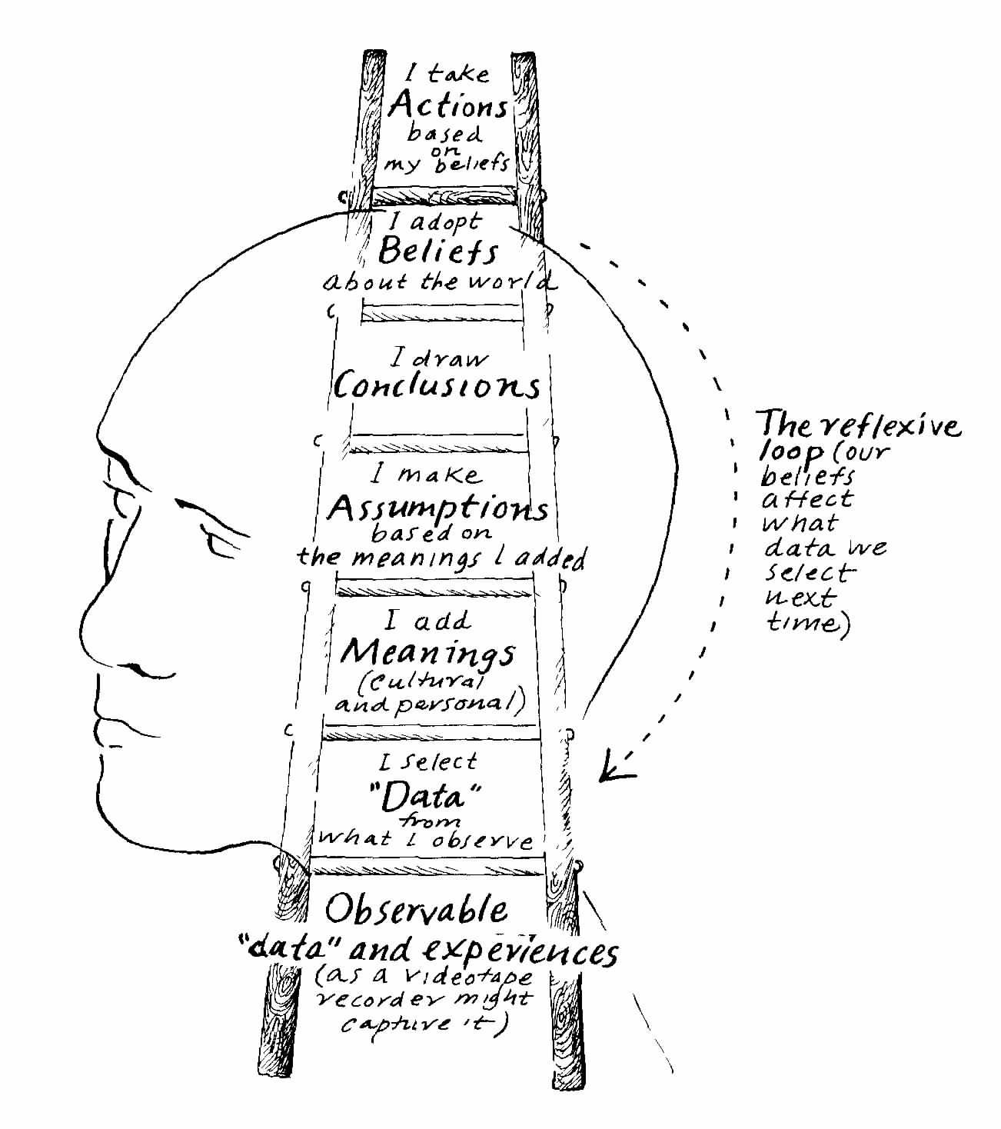

**The Four Elements of Cultural Competence Aligned with EfS Standards** (in red)**:**

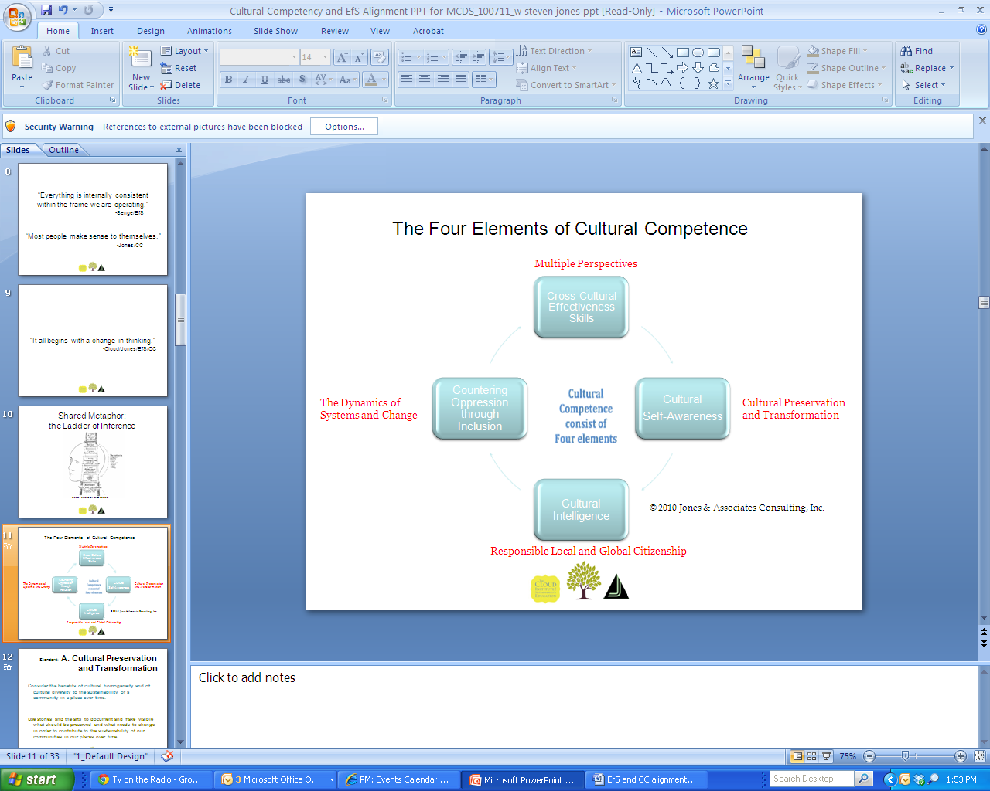

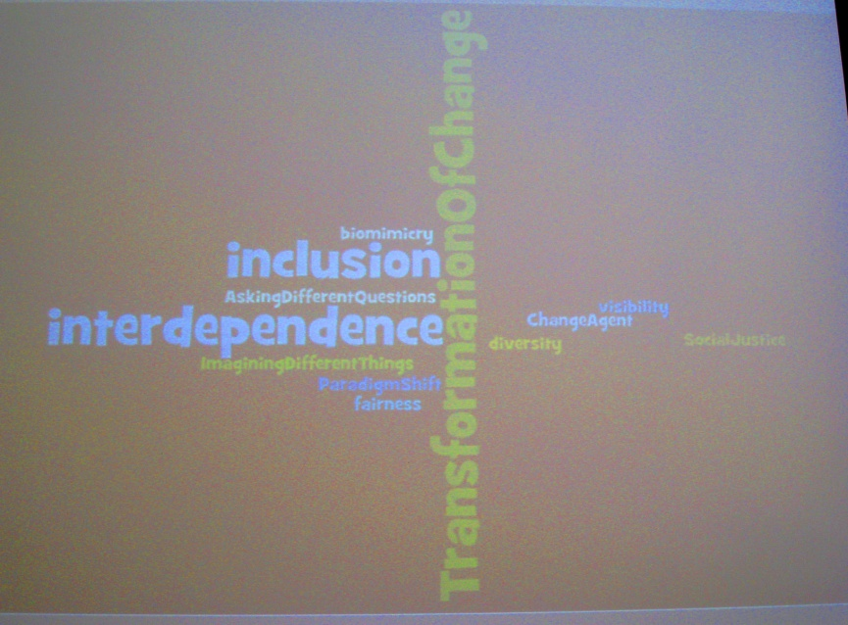

**Selected Standards and Performance Indicators that are both EfS and CC:**

**Standard: A. Cultural Preservation and Transformation**

* Consider the benefits of cultural homogeneity and of cultural diversity to the sustainability of a community in a place over time.
* Use stories and the arts to document and make visible what should be preserved and what needs to change in order to contribute to the sustainability of our communities in our places over time.

**Standard: B. Responsible Local/Global Citizenship**

* Form an opinion about the requirements of responsible local, national, and global citizenship by synthesizing diverse perspectives on participation and governance.
* Demonstrate individual and collective respect for themselves and the Commons.

**Standard: C. The Dynamics of Systems & Change**

* See the whole system, its parts, and their place within the system.
* Define what a system is and determine if things are or are not systems.

**Standard: D. Sustainable Economics**

* Illustrate their understanding of the relationships among ecological, economic and social systems.
* Calculate the buying power of their generation per year and take responsibility for contributing to a sustainable future by changing their consumption patterns.

**Standard: E. Healthy Commons**

* Develop criteria to reconcile the conflicts that exist between our individual rights and our responsibilities as citizens to tend the Commons, in relation to specific Commons.

**Standard: F. Natural Laws and Ecological Principles**

* Demonstrate awareness of the importance of a great diversity of life (biodiversity) to the long-term sustainability of humankind and other living species on Earth.

**Standard: G. Inventing and Affecting the Future**

* Develop visioning skills to create a healthy and sustainable future.
* Distinguish goals from indicators (problems from symptoms).
* Identify the most upstream problems to address within their sphere of influence.

**Standard: H. Multiple Perspectives**

* Seek to determine the interests that underlie people’s positions and behaviors.
* Identify Author’s Purpose. (Oregon Reading Standard)
* Distinguish Positions from Interests (Win Win Negotiation: Getting to Yes, Fisher and Ury, Harvard School of Negotiation)

**Standard: I. A Sense of Place**

* Create a celebration of the unique cultural character of a place.
* Engage in goal setting/future visioning.

**Visualizations of EfS and CC synergies:**

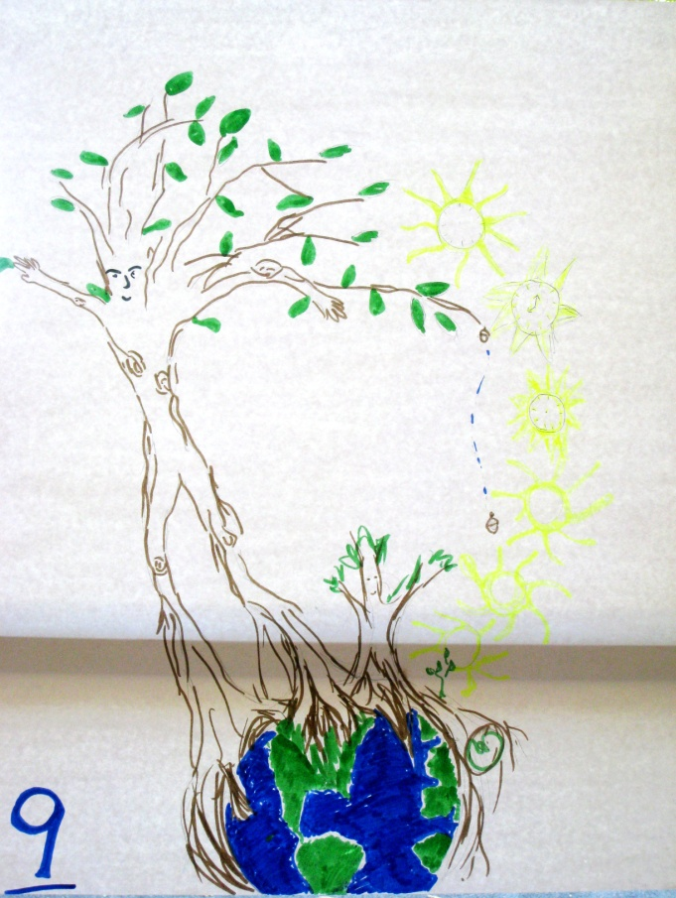 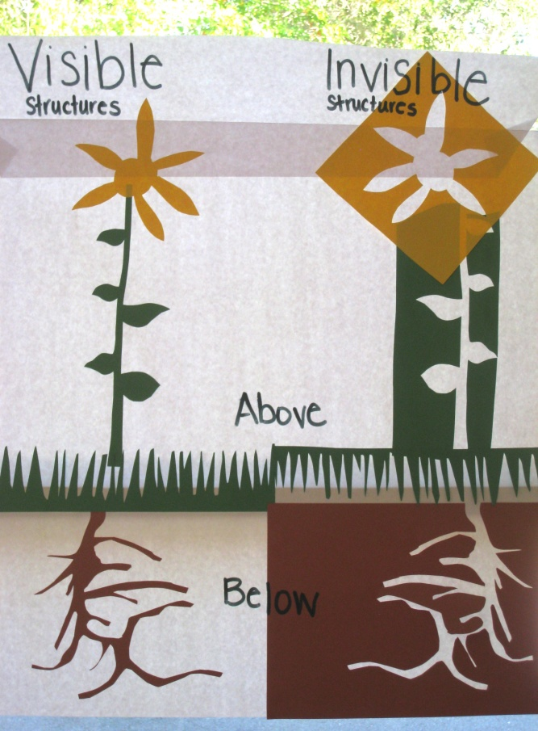

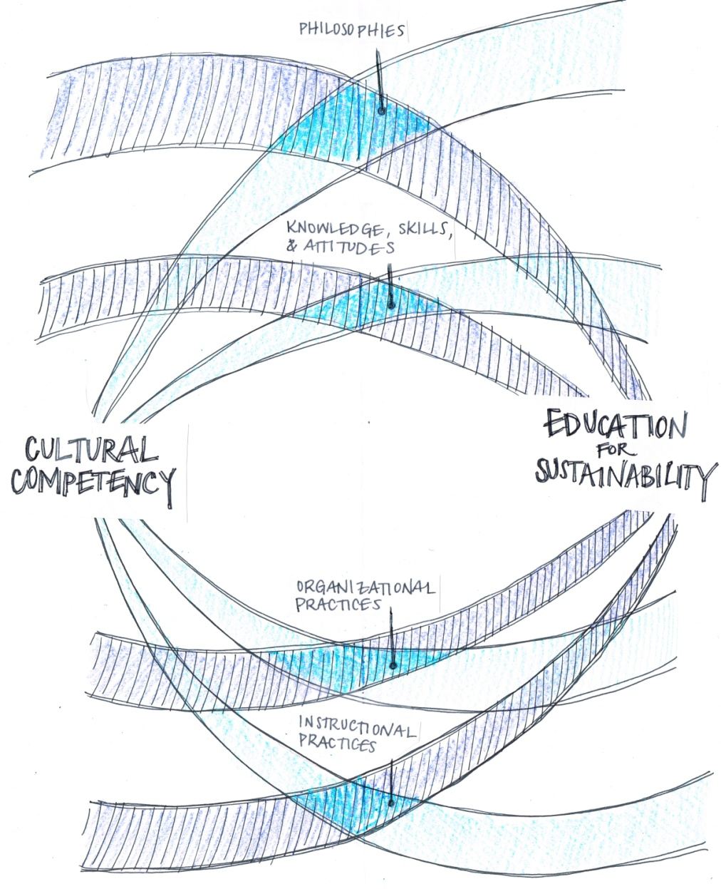

**EfS & CC: Shared Philosophies**

* All students can learn and can meet high standards.
* All students have the right to be honored as individuals.
* Diversity makes our lives possible and contributes to resilience (at all levels).
* Reflective practices improve education .
* Understanding EfS and Cultural Competency can strengthen educational curriculum and practices.
* EfS and Cultural Competency standards can act as a hub for building collective capacities and strategic vision amongst all stake holders in the service of the future we want.

**EfS & CC: Shared Instructional Practices**

* Educators use standards and assessment-driven curricula and instruction to provide the support and the challenges necessary for individual students to recognize and achieve their educational potential.
* Educators continually read the feedback (assess and analyze) to improve practices over time.
* Educators use backwards design to create and implement interdisciplinary curricula that integrates principles of EfS and cultural competency.
* Educators incorporate place-based methodologies to incorporate local ways of knowing and an understanding of historical and cultural knowledge relevant to their work.
* Educators use constructivist approaches to teaching, authentic instruction and assessment, learner-centered instruction, cooperative learning and differentiation to encourage student engagement, honor different learning styles, and provide multiple opportunities for students to share what they know.
* Educators use their understanding of EfS and Cultural Competency to create more opportunities for diverse and authentic student engagement.
* Educators use curriculum design and instructional methodologies to produce authentic and engaged learning.

**EfS & CC: Shared Organizational Practices**

* Educators conduct a strengths assessment and review gaps in curriculum and programming to inform the practices of the school and teachers.
* Educators fully integrate EfS and CC into the scope and sequence of the school’s curriculum.

**EfS and CC Share the Following Attributes:**

Learning to action: emphasis on applied learning

* We can learn, and we can change things in the service of the future we want
* Focus on self assessment, continuous improvement, life-long learning, growth, and the growth mindset
* Reflective thinking and practice
* Meta-cognitive skill development: thinking about our thinking
* Thinking drives behavior and behavior causes results
* Read the feedback
* We are all responsible for the difference we make
* Recognition that a system’s structure generates its behavior
* Richness is in the dynamics of the relationships between the parts
* The importance of surfacing and testing assumptions and mental models, biases, beliefs, and privileges
* The power of visioning and creativity in inventing the future we want
* CELEBRATION!

